23CSE111

OBJECT-ORIENTED PROGRAMMING

LAB REPORT



Department of Computer Science and Engineering

Amrita School of Engineering

Amrita Vishwa Vidyapeetham, Amaravati Campus

Verified by: NAME: G.Sahithi

ROLL NO:AV.SC.U4CSE24122

|  |  |  |  |  |
| --- | --- | --- | --- | --- |
| **S.No** | **Title** | Date | Page No. | Signature |
| Week 1 |  |  |  |  |
| 1. | How to download and install Java Software. |  |  |  |
| 2. | Write a Java Program to print the message “Welcome to Java Programming”. |  |  |  |
| 3. | Write a Java program that prints: Name, Roll.no. section of a student. |  |  |  |
| Week 2 |  |  |  |  |
| 1. | Write a java program to calculate the area of a rectangle. |  |  |  |
| 2. | Write a java program to temperature from Celsius to Fahrenheit and vice-versa. |  |  |  |
| 3. | Write a java program to calculate the simple interest. |  |  |  |
| 4. | Write a java program to find the largest of three numbers, using ternary operator. |  |  |  |
| 5. | Write a java program to find the factorial of a number. |  |  |  |
| Week 3 |  |  |  |  |
|  | To create a java program with the following instructions:   1. Create a class name “car” 2. Create 4 attributes named car_color, car_brand, fuel_type and mileage 3. Create 3 methods names start (), stop () and service (). 4. Create 3 objects named car1, car2 and car3 5. Create a constructor which should print “welcome to car garage”. |  |  |  |
|  | To write a java program to create a class named BankAccount, with 2 methods deposit () and withdraw ().   1. Deposit (): Whenever an amount is deposited, it has to be updated the current amount. 2. Withdraw (): Whenever an amount is withdrawn, it has to be less than the current amount, else print (“Insufficient funds”). |  |  |  |
| Week 4 |  |  |  |  |
| 1. | Write a java program with class named “book”. The class should contain various attributes such as “title_of_the_book”, “author”, “year_of_publication”. It should also contain a constructor with the parameters which initializes “title_of_the_book”, “author”, “year_of_publication”. Create a method which displays the details of the book, that is “author”, “title_of_the_book”, “year_of_publication”. Display the details of two books by creating two objects. |  |  |  |
| 2. | To create a java program with class name “my_class” with a static variable “count” of “int” type, initialized to zero and a constant variable “pi” of type double initialized to “3.1415” as attributes of that class. Define a constructor for “my_class” that increments the count variable each time an object of my_class is created. Finally print the values of “count” and “pi” |  |  |  |

WEEK 1

PROGRAM – 1

AIM: How to download and install java software

PROCEDURE: The procedure for downloading the software is written below.

Step 1: Downloading JDK21

1. Open your default web browser and go to the search bar and type Oracle JDK Downloads page.
2. Scroll down and click on Java SE Development Kit21 section.
3. Choose “Windows x64” Installer version.
4. Click on Downloads and wait for the whole installation to get completed.

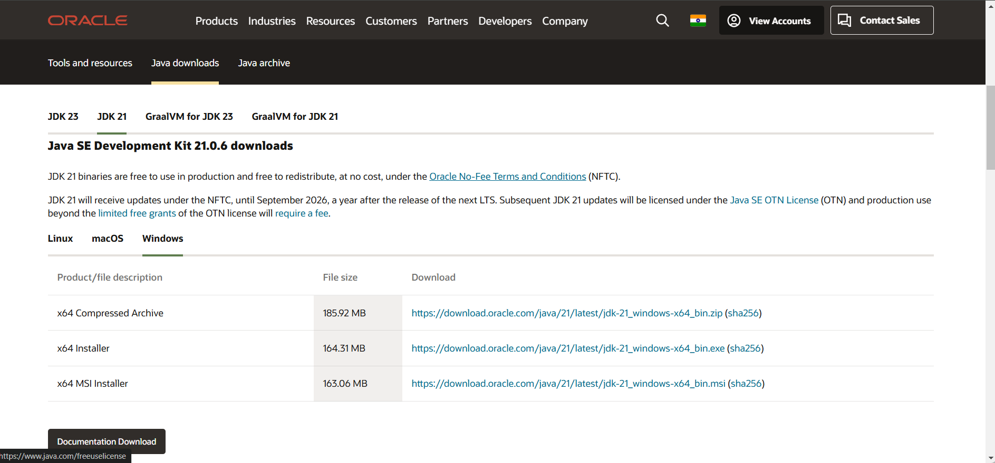

Step 2: Installing of JDK21

1. Locate the downloaded document jdk-21_windows-x64_bin.exe file.
2. Double-click on it and launch the installer.
3. Click on the next simultaneous steps.
4. Choose the installation path (C:/ProgramFiles/java/jdk-21).
5. Click on the next step and install it.
6. Wait for the process of installation to get completed.
7. Click on the close button and the whole installation is completed.

Step 3: Setting up the path of Java program

1. Access the “windows c: drive” on your laptop.
2. Choose the program files option and click on java, then click on JDK version 21, and then select the bin option.
3. Copy the path address at the top.

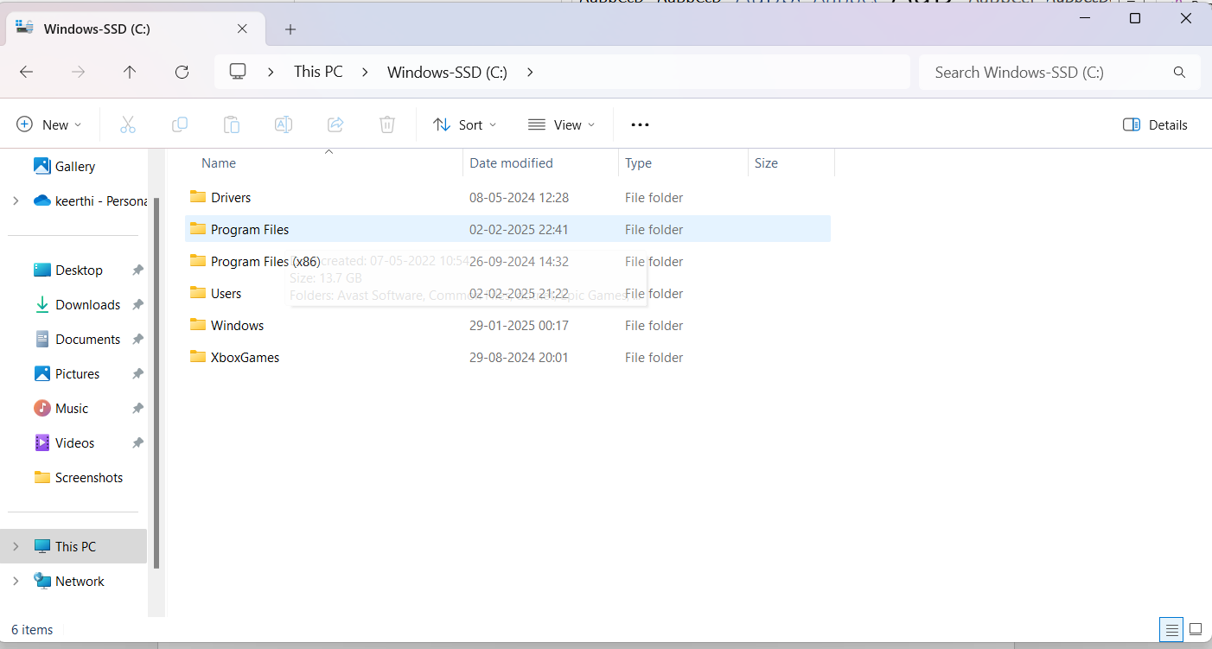

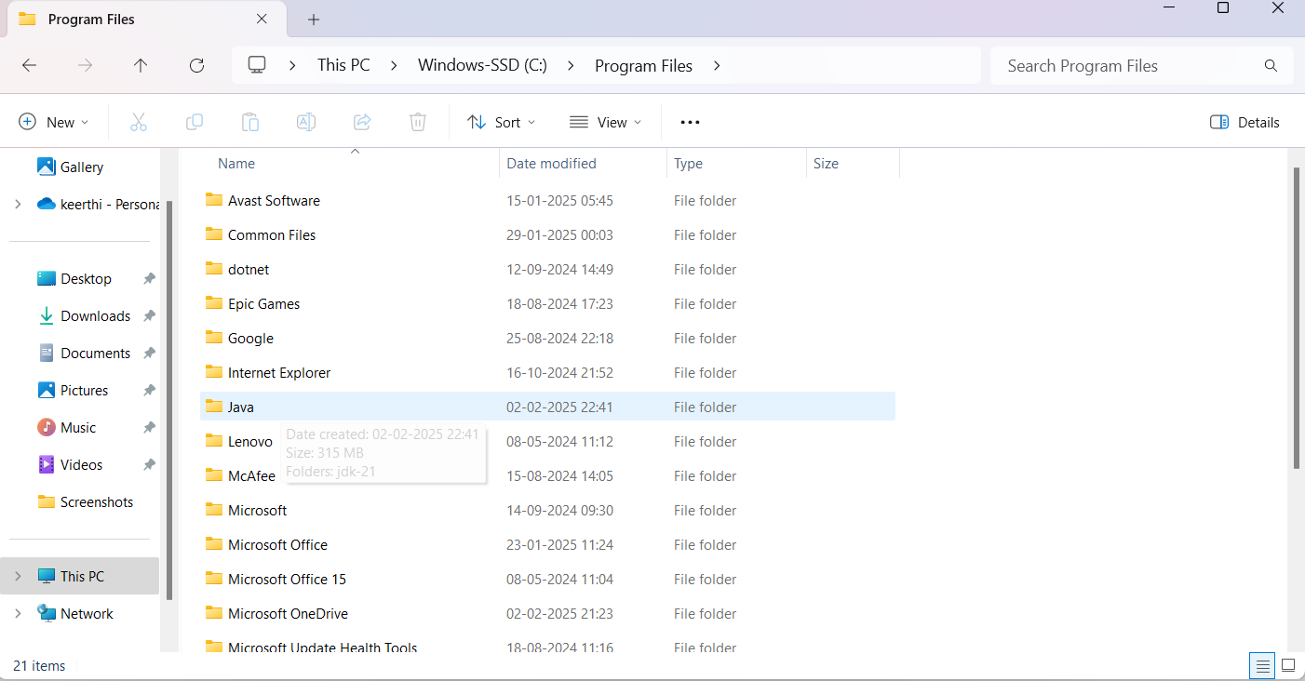

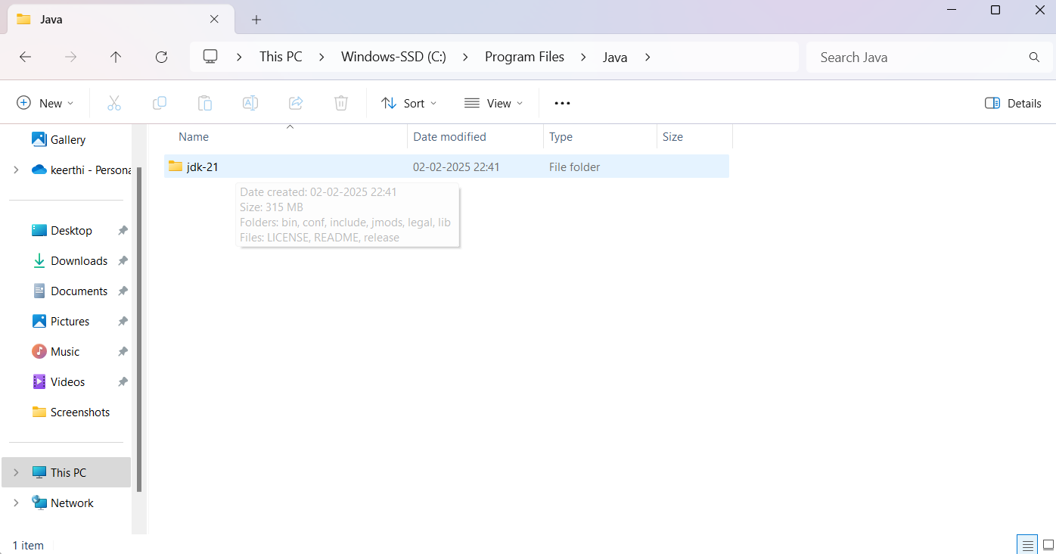

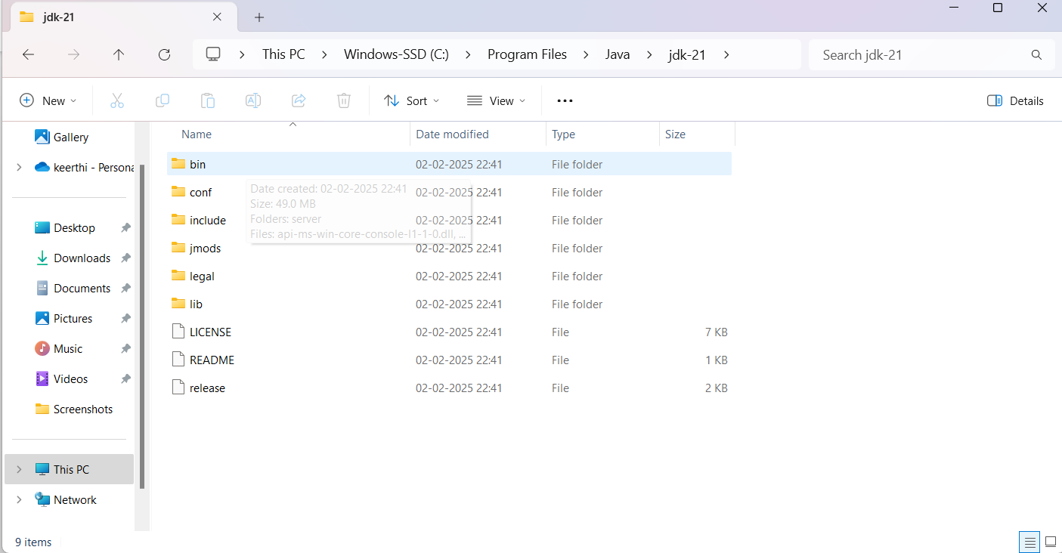

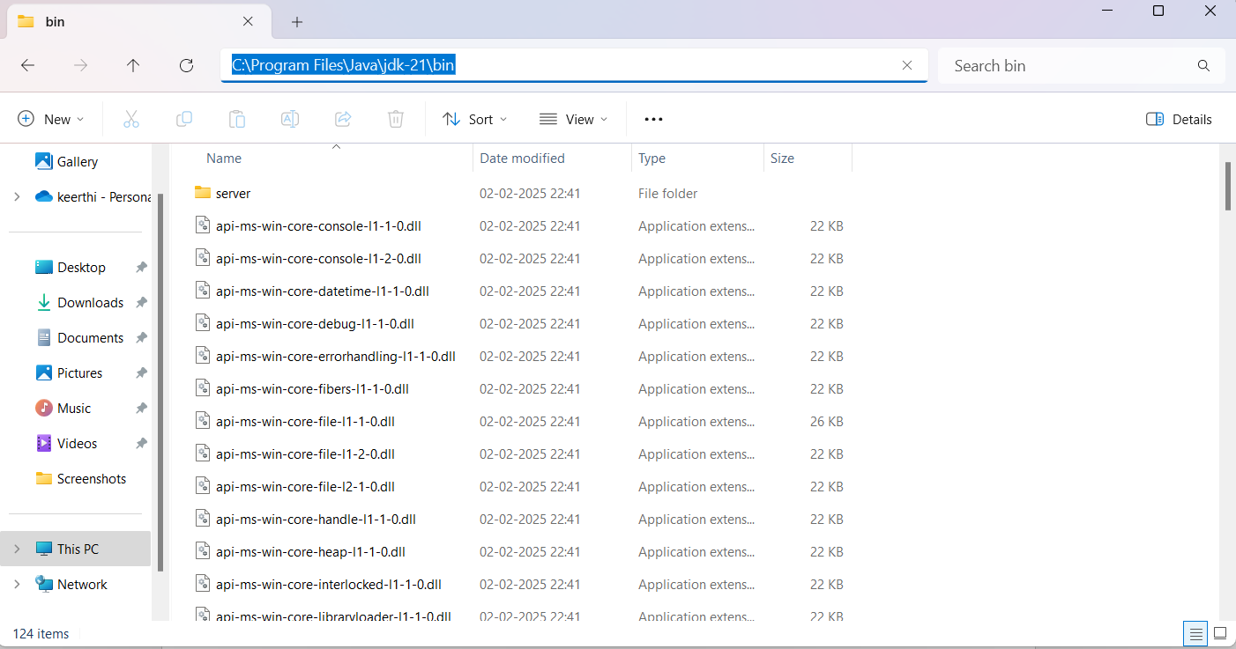

Step 4: Accessing the system properties.

1. Press the windows + R option and type sysdm.cpl, and click on the option “ok”.
2. The system properties will open.
3. Then click on the Advanced tab.
4. Go to the environment variables present at the bottom.

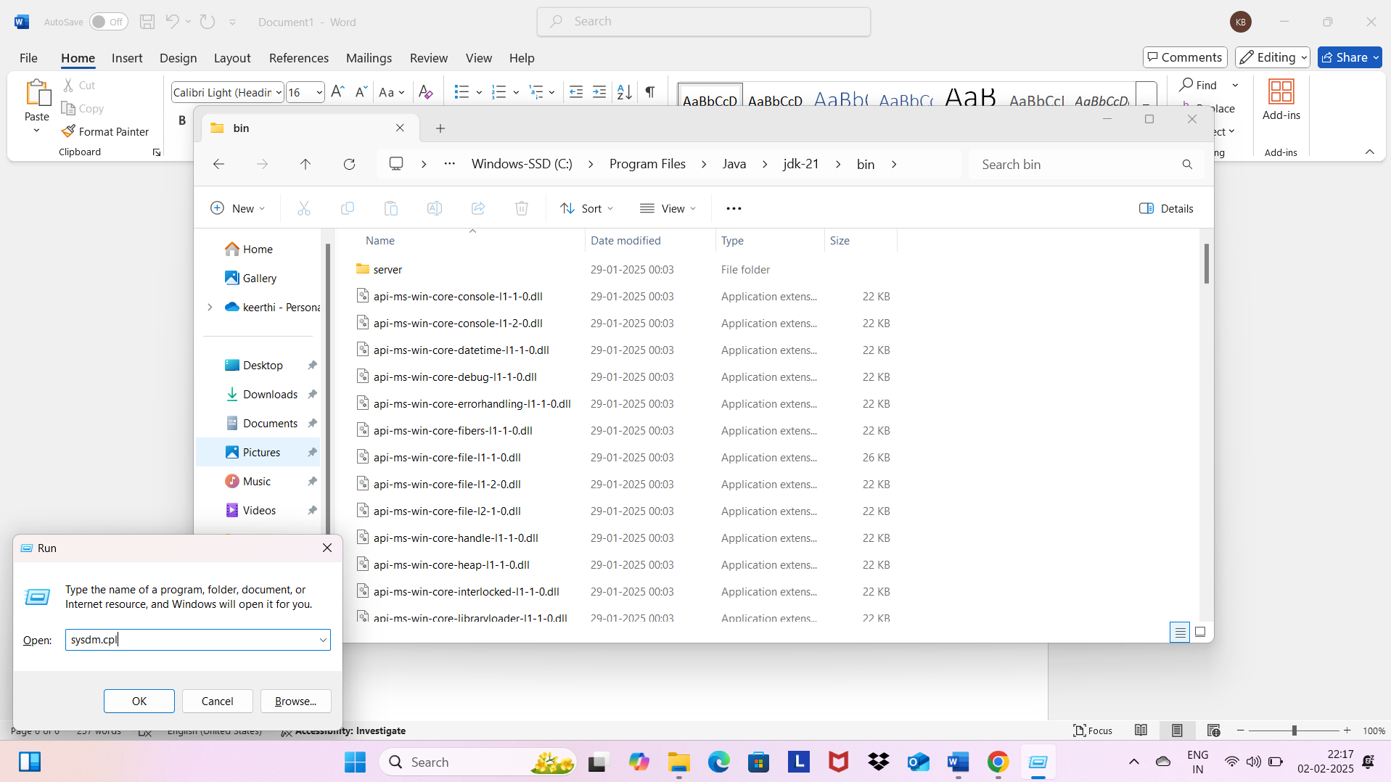

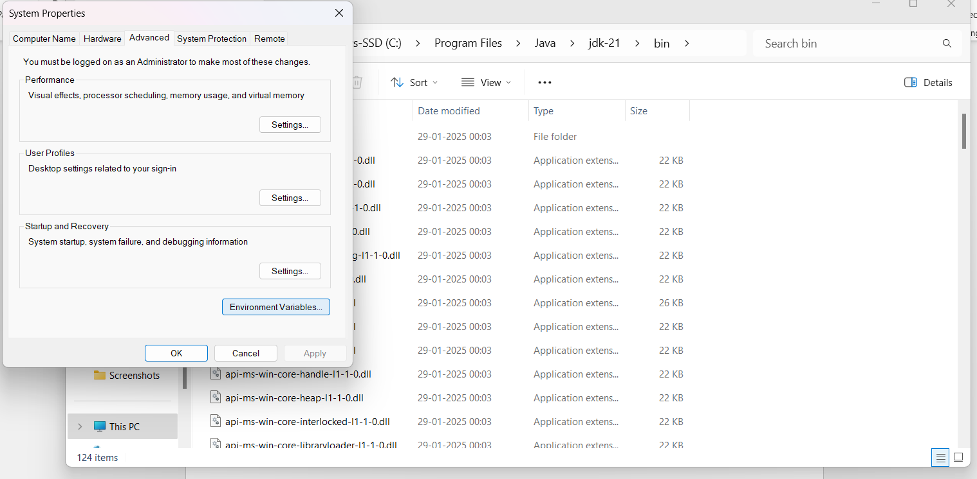

Step 5: Setting up JAVA_HOME

1. Under the system variables option click on the option “new”.
2. Type out the name as JAVA.HOME.
3. Set the variable value as the installation path.
4. Click on the function “ok”.

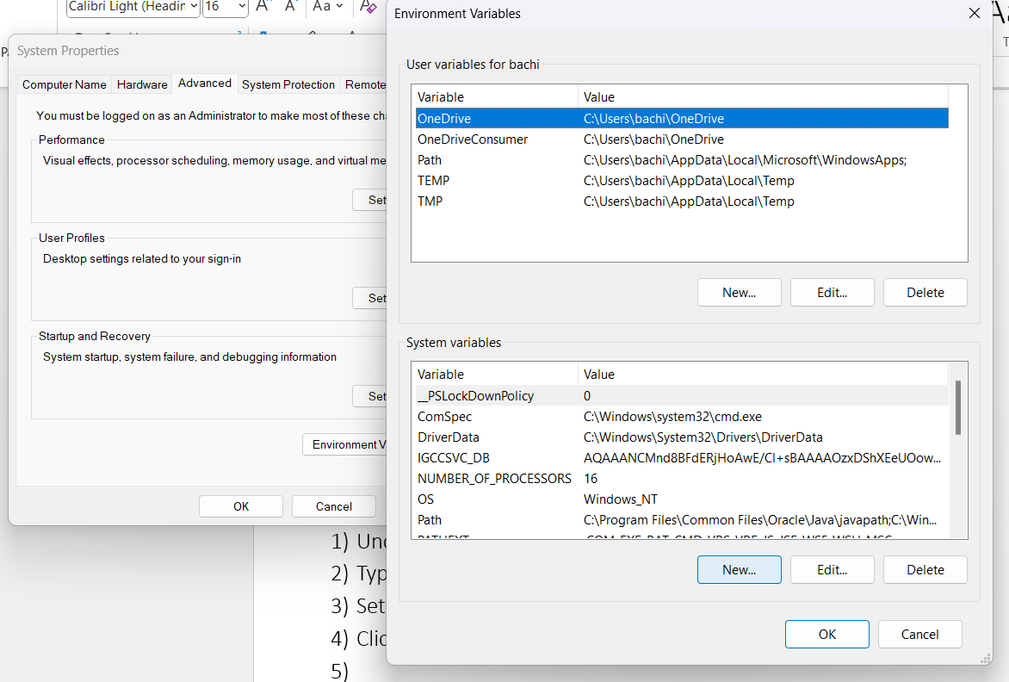

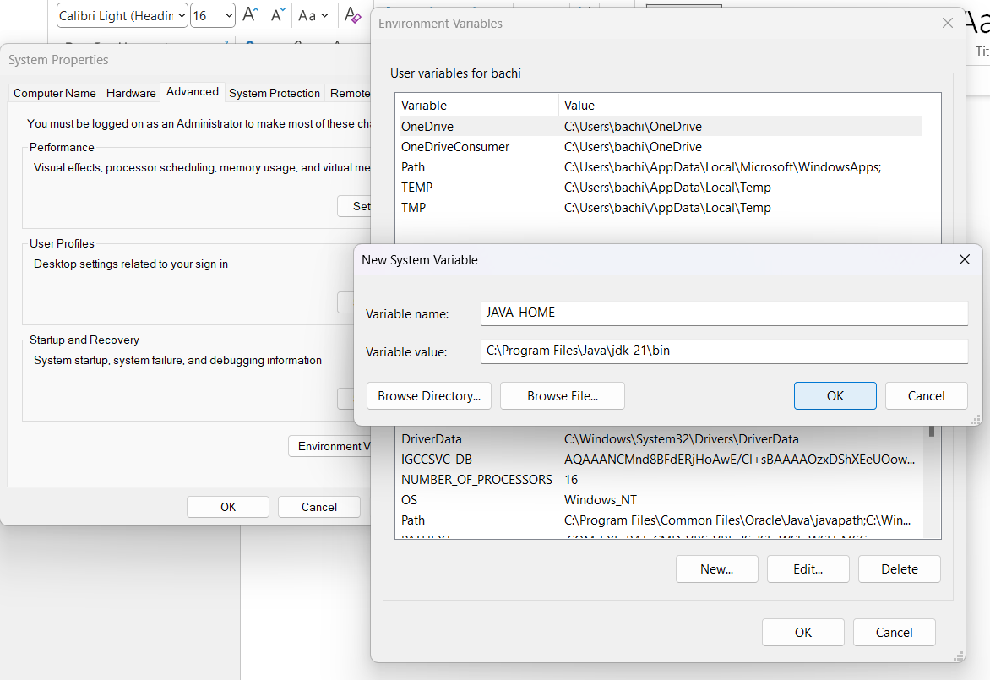

Step 6: Updating the PATH variable.

1. In the system variable option, find the path and click on edit option.
2. Click on the new option and add C:\Program Files\Java\jdk-21\bin.
3. Click on OK to save.

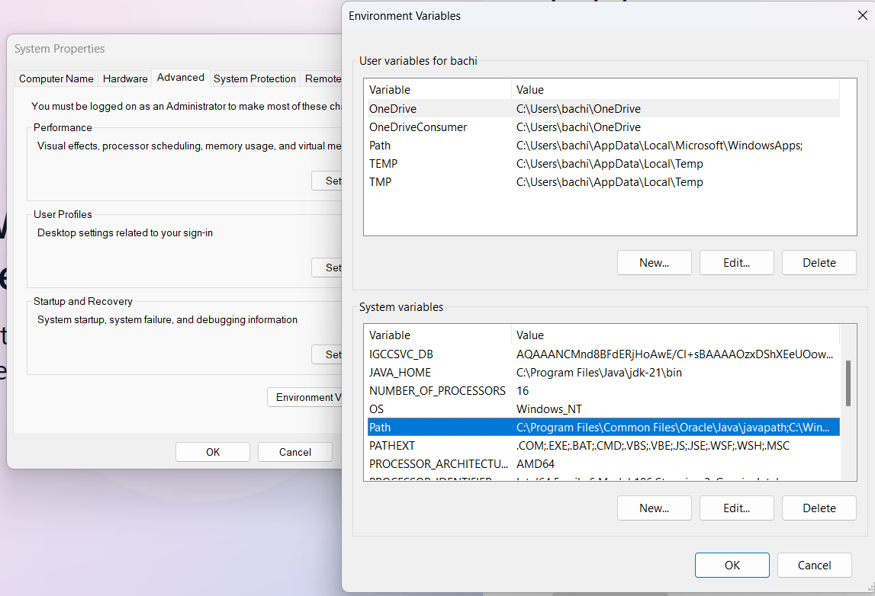

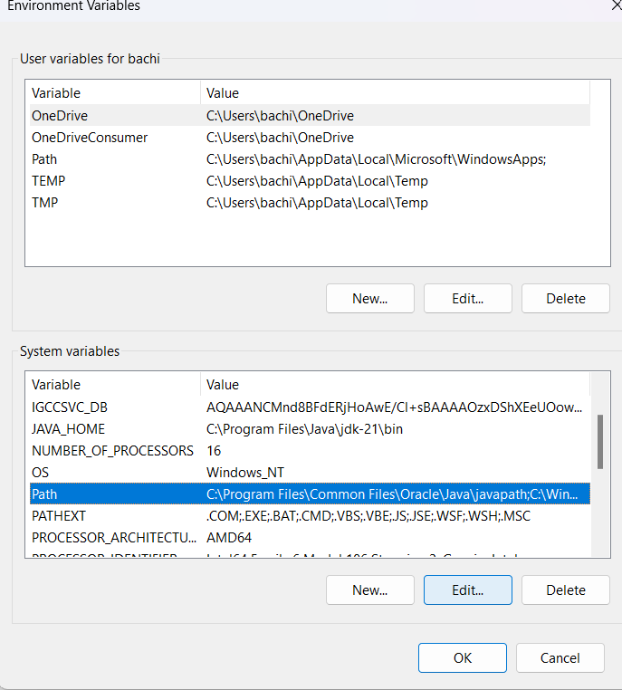 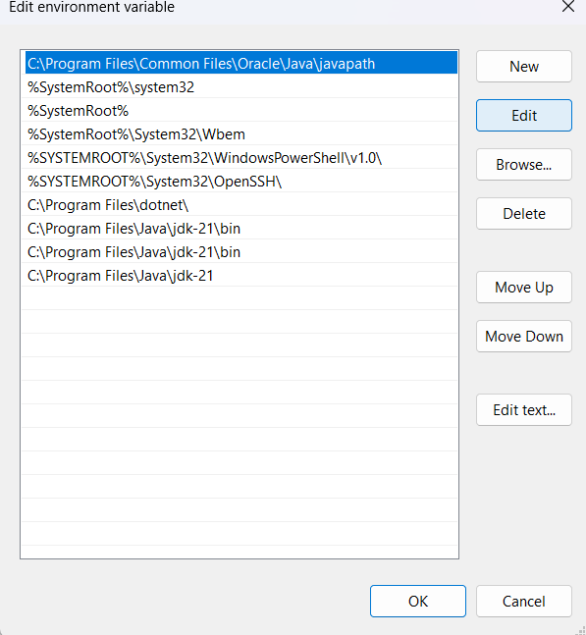

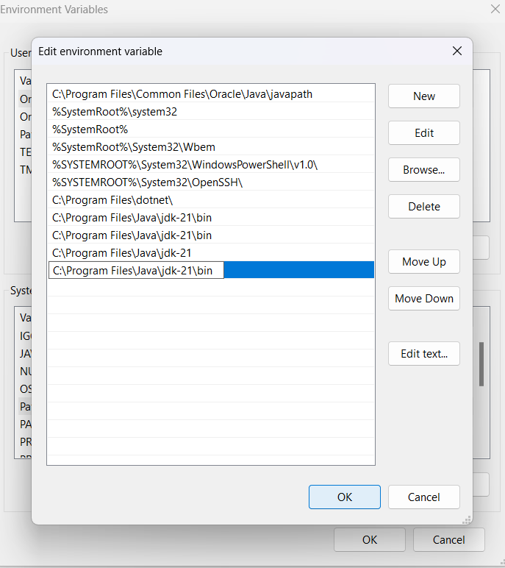

Step 7: verifying the process of installation.

1. Click on the command prompt in your system.
2. Type out the command, **java --version** and click on enter.

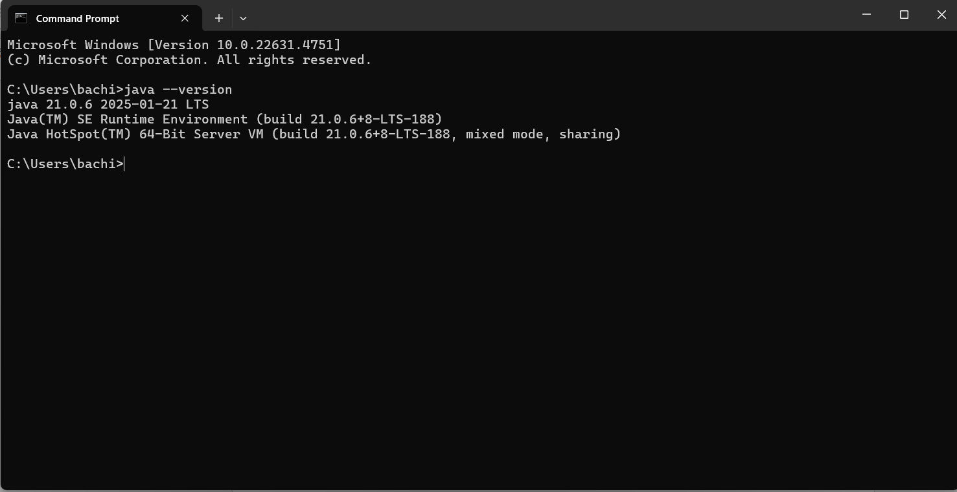

1. We can also check the compiler version by typing out the following command.

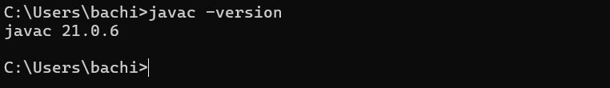

PROGRAM 2:

AIM: To write a java program and print the message “Welcome to Java Programming”.

INPUT:

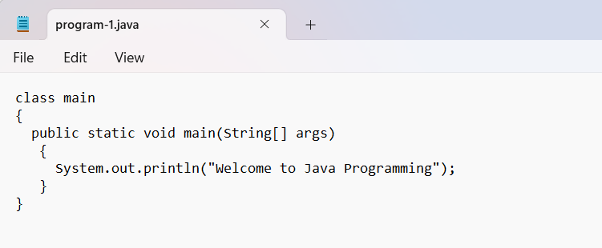

OUTPUT:

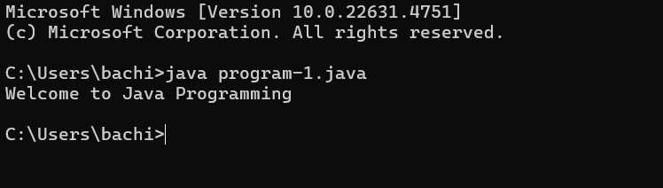

ERRORS: No errors were to be found.

PROGRAM 3:

AIM: Writing of a java program to print out name, roll no., and section of a student.

INPUT:

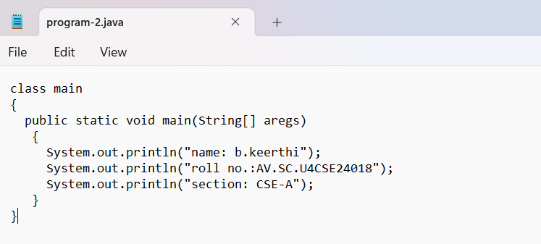

OUTPUT:

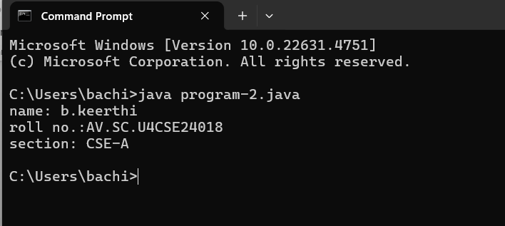

ERRORS: No errors were found as of the program.

WEEK 2

PROGRAM – 1:

AIM: write a java program to calculate the area of the rectangle.

INPUT:

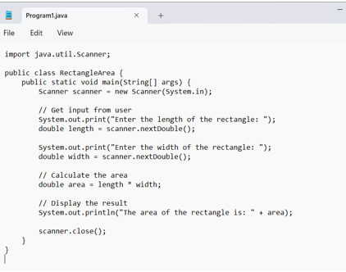

ERRORS:

|  |  |  |
| --- | --- | --- |
| **Sno.** | **Error message** | **Error rectification** |
| 1. | Error: <identifier> expected. Public static void main. Compilation failed | Public Static void main (String [ ] args) |

OUTPUT:

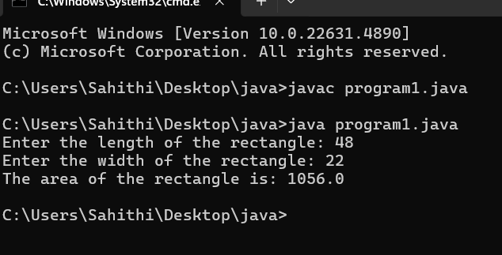

CONCEPTS KNOWN:

* Import java.util.Scanner – used to accept inputs from the user, under the util package has to be imported.
* Scanner input=new Scanner(System.in); - Used to create a Scanner object
* int ln=input.nextInt(); - Used to read the integer data type stored under the object created
* System.out.println(“ “); - It is used to print string inside the quotes. After printing, the cursor moves to the beginning of the next line.

PROGRAM 2

AIM: Write a java program to convert temperature from Celsius to Fahrenheit and vice-versa.

INPUT:

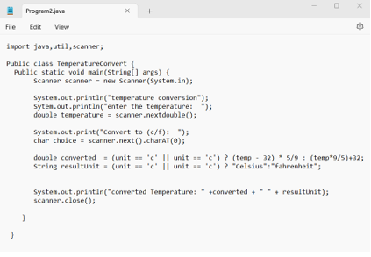

ERRORS:

|  |  |  |
| --- | --- | --- |
| **SNO.** | **Error message** | **Error rectification** |
| 1. | Error: ‘. ‘expected | Remove the ‘ , ‘ symbol and replace with the correct symbol |
| 2. | Error: class, interface, enum, or record expected | Static is written correctly |
| 3. | Error: <identifier> expected | Static is written correctly |

OUTPUT:

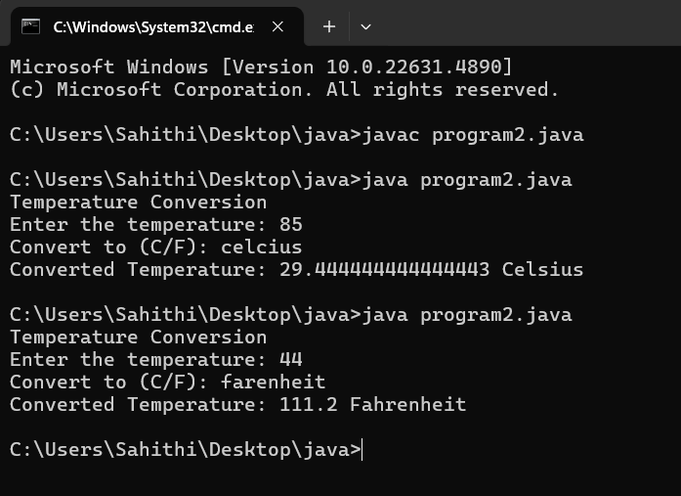

CONCEPTS KNOWN:

* import java. util. Scanner; - To accept input from user, Scanner class under util package has to be imported.
* Scanner input=new Scanner (System.in); - Used to create a Scanner object
* double fh=input. next Double (); - Used to read double data type stored under the object created
* System.out.println(““); - It is used to print string inside the quotes. After printing, the cursor moves to the beginning of the next line.

PROGRAM-3

AIM: Write a java program to calculate the simple interest.

INPUT:

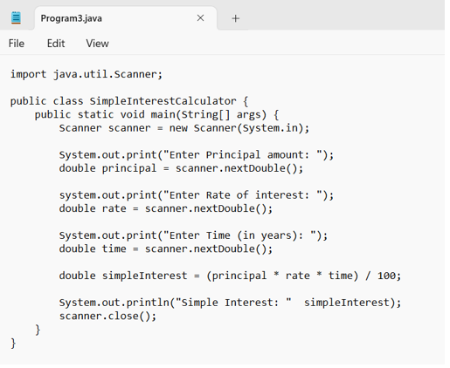

ERRORS:

|  |  |  |
| --- | --- | --- |
| **SNO** | **Error message** | **Error rectification** |
| 1. | Error: ‘) ‘or ‘, ‘is expected | Error rectified at line 5 |
| 2. | Error: not a statement | Statement has been verified at line 5 |
| 3. | Error: ‘; ‘is expected | Error rectified at line 6 |

OUTPUT:

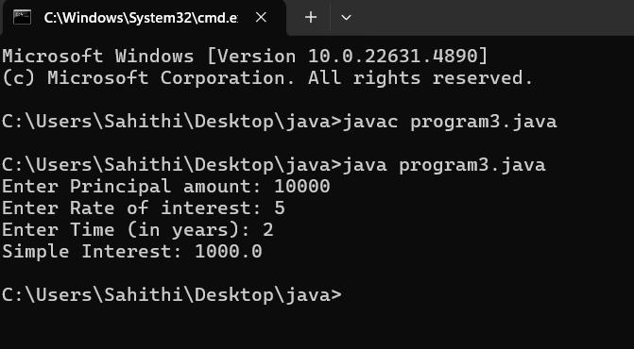

CONCEPTS TO KNOW:

* import java. util.Scanner; - To accept input from user, Scanner class under util package has to be imported.
* Scanner input=new Scanner (System.in); - Used to create a Scanner object
* double p=input. Next Double (); - Used to read double data type stored under the object created
* System.out.println (““); - It is used to print string inside the quotes. After printing, the cursor moves to the beginning of the next line.

PROGRAM 4:

AIM: Write a java program to find the largest of three numbers, using ternary operator

INPUT:

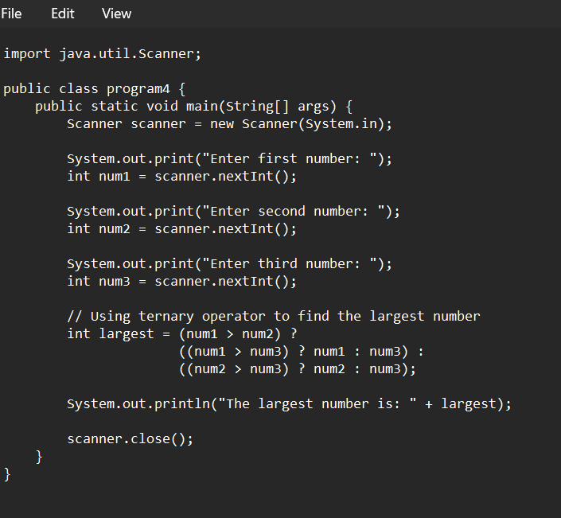

ERRORS:

|  |  |  |
| --- | --- | --- |
| **SNO** | **Error message** | **Error rectification** |
| 1. | Error: package ava.util does not exist | Error rectified and changed to java. util |
| 2. | Error: cannot find the symbol | A symbol “= “which is missed is written again. |
| 3. | Error: cannot find the symbol | Missed symbol is replaced. |
| 4. | Error: package system does not exist | A symbol ‘. ‘Which has been missed is written. |
| 5. | Error: cannot find symbol | The symbol ‘; ‘is written |

OUTPUT:

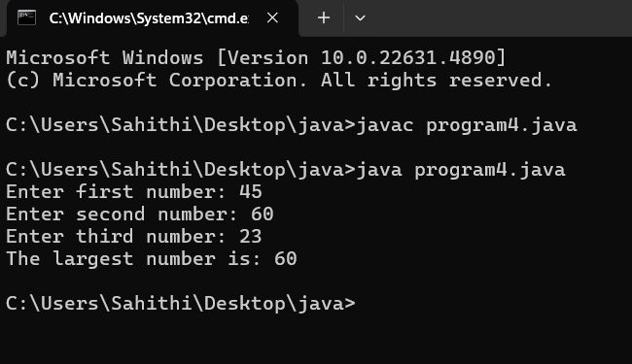

CONCEPTS KNOWN:

* import java.util.Scanner; - To accept input from user, Scanner class under util package has to be imported.
* Scanner input=new Scanner(System.in); - Used to create a Scanner object
* int a=input.nextInt (); - Used to read integer data type stored under the object created
* int result=(a>b)? ((a>c)? a:c): ((b>c)? b:c); - Nested Ternary operator is used here.
* Syntax for ternary operator is- condition? expression 1: expression 2; whose answer is stored in a variable and then used.

PROGRAM 5:

AIM: Write a java program to find the factorial of a number.

INPUT:

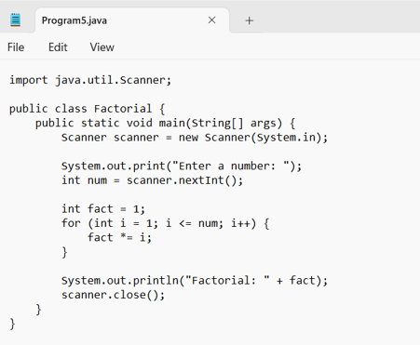

ERRORS:

|  |  |  |
| --- | --- | --- |
| **SNO.** | **Error message** | **Error rectification.** |
| 1. | Error: class, interface, enum, or record is expected. | The word factorial has been replaced |
| 2. | Error: unnamed classes are a preview feature and are disabled by default. | The word “static” has been replaced with “Static” |
| 3. | Error: class, interface, enum, or record expected | The symbol ‘} ‘has been removed. |

OUTPUT:

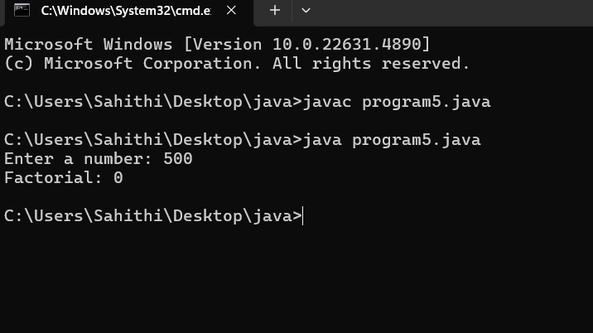

CONCEPTS KNOWN:

* for (int i=1; n>=i; --n) {} - For loop syntax: for (initial expression; test expression; update expression {} The loop is executed, until the test expression evaluates to be false

WEEK – 3

PROGRAM 1:

AIM: To create a java program with the following instructions:

1. Create a class with name “Car”
2. Create 4 attributes, named: car_color, car_brand, fuel_type, mileage
3. Create 3 methods, named: start (), service (), stop ()
4. Create 3 objects, named: car1, car2, car3
5. Create a constructor, which should print, “Welcome to car garage”.

CLASS DIAGRAM:

|  |
| --- |
| Car |
| + car_color: String  + car_brand: String  + fuel_type: String  + mileage: int |
| + Car (): void  + start (): void  + service (): void  + stop (): void |

INPUT:

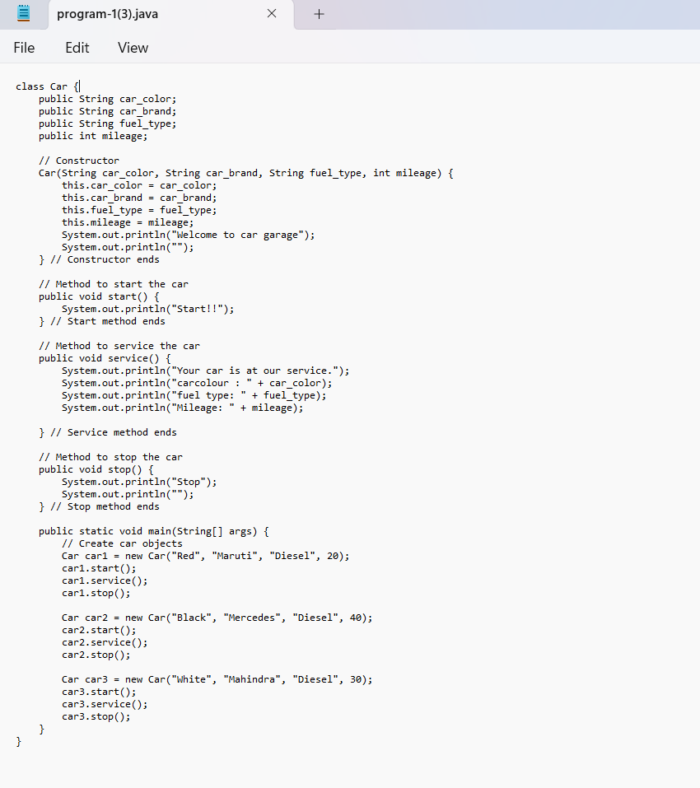

ERRORS:

|  |  |  |
| --- | --- | --- |
| Sno. | Error message | Error rectification |
| 1. | error: ';' expected car1.start() | Add a “;”  car1.start(); |
| 2. | error: illegal start of type  public void stop () | Add a “)”  public void stop () { |
| 3. | error: cannot find symbol thiscar_brand=car_brand; | Add a “.”  this.car_brand=car_brand; |

OUTPUT:

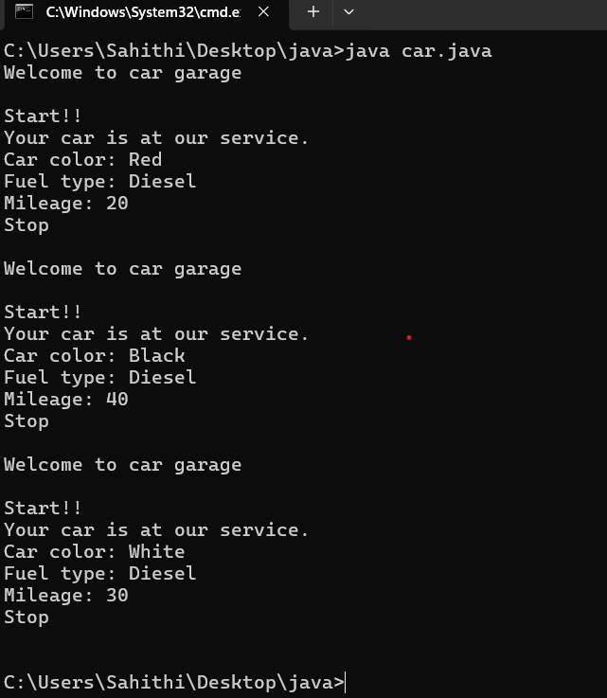

CONCEPTS KNOWN:

* public String car_color; - Used to declare a variable named car_color, with data type as String with public accessibility.
* Car (String car_color, String car_brand, String fuel_type, int mileage) { } – It is a constructor (method with name same as class), which requires parameters such as car_color (String data-type) and so on.
* this.car_color=car_color; - “this” is a default method, which is used to point to the instance variables.
* public void start () {} – used to declare a method, which will return nothing(void) in public accessibility.

PROGRAM 2:

AIM: To write a java program to create a class named Bank Account, with 2 methods deposit () and withdraw ().

1. Deposit (): Whenever an amount is deposited, it has to be updated with the current amount.
2. Withdraw (): Whenever an amount is withdrawn, it has to be less than the current amount, else print (“Insufficient funds”)

CLASS DIAGRAM:

|  |
| --- |
| BankAccount |
| - name: String  - Accno: int  - CurrBal: int |
|  |

INPUT:

ERRORS:

|  |  |  |
| --- | --- | --- |
| **Sno.** | **Error message** | **Error rectification** |
| 1. | error: ';' expected cust1.withdraw(3050) | Add a “;”  cust1.withdraw(3050); |
| 2. | error: cannot find symbol thisCurrBal=CurrBal; | Add a “.”  this.CurrBal=CurrBal; |

OUTPUT:

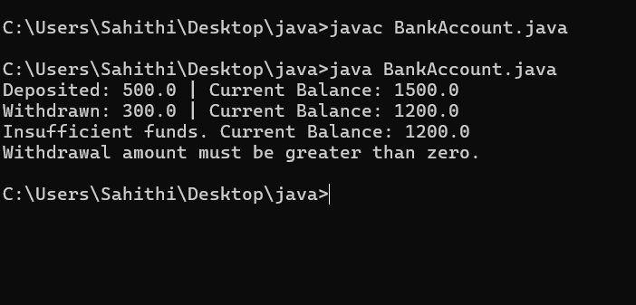

CONCEPTS KNOWN:

* private String name; - Used to declare a variable named name, with data type as String with private accessibility.
* BankAccount (String name, int Accno, int CurrBal) {} – It is a constructor (method with name same as class), which requires parameters such as name (String data-type) and so on.
* this.CurrBal=CurrBal; - “this” is a default method, which is used to point to the instance variables.
* public void withdraws (int WAmt) {} – used to declare a method, which will return nothing(void) in public accessibility, which requires a parameter WAmt (integer data type).
* public int deposit (int DAmt) {} - used to declare a method, which will return integer data type in public accessibility, which requires a parameter DAmt (integer data type).
* BankAccount cust1=new BankAccount("Ram",5587,20000); - used to create an object in class BankAccount, with object name as cust1.
* cust1.withdraw(50000); - Calling a method, under object cust1, by passing a parameter.
* System.out.println("Your current balance after depositing money is:"+cust1.deposit(25000)); - Deposit method will return the value, which will be directly printed

WEEK-4

PROGRAM-1:

AIM: Write a java program with class named “book”. The class should contain various attributes such as “title_of_the_book”, “author”, “year_of_publication”. It should also contain a constructor with the parameters which initializes “title_of_the_book”, “author”, “year_of_publication”. Create a method which displays the details of the book, that is “author”, “title_of_the_book”, “year_of_publication”. Display the details of two books by creating two objects.

CLASS DIAGRAM:

|  |
| --- |
| Book |
| - title: String  - author: String  - yearOfPublication: int |
| + Book(title, author, yearOfPublication)  + displayDetails(): void |

INPUT:

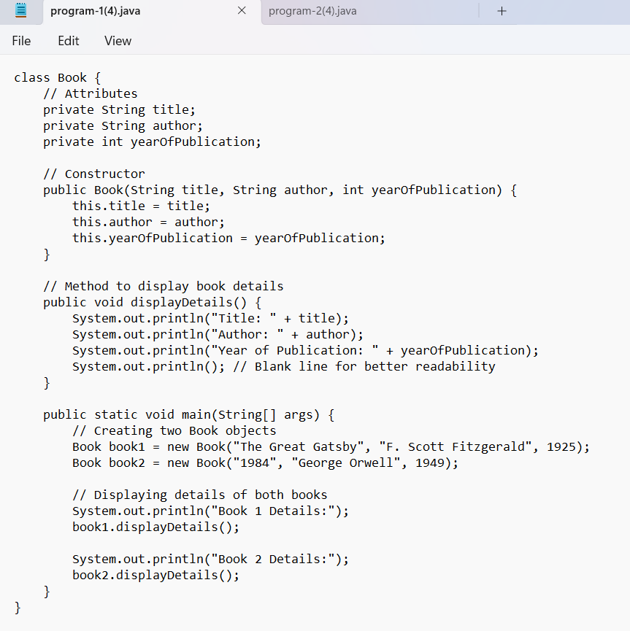

**ERRORS:**

|  |  |  |
| --- | --- | --- |
| **Sno.** | **Error message** | **Error rectification** |
| 1. | Error: ‘;’ is expected | In line no.16 the required symbol is added. |
| 2. | Error: cannot find the symbol | Line 5 string changed to int and S is capital is string. |
| 3. | Error: ‘)’ and ‘;’ is expected | The space at the last line is removed. |
| 4. | Error: class, interface, enum or record expected | Additional symbol ‘{‘ is removed at the end. |

OUTPUT:

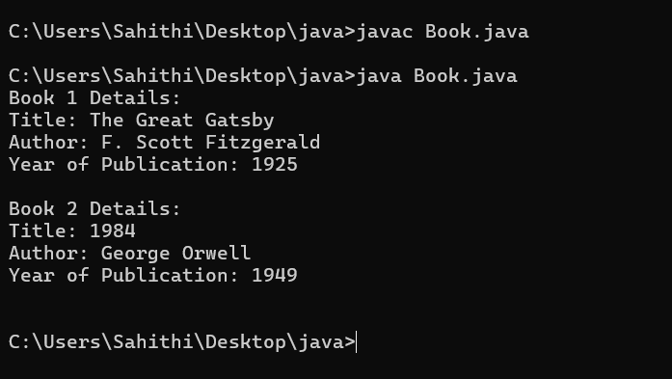

CONCEPTS KNOWN:

* The Book class defines the attributes and behavior of a book.
* Objects (book1 and book2) are created from the Book class.
* The attributes (title, author, yearOfPublication) are declared private to restrict direct access.
* Getter and setter methods could be added to allow controlled access.
* Two objects, book1 and book2, are created using the new keyword.
* The System.out.println() function is used to display book details.

PROGRAM-2

AIM: To create a java program with class name “my_class” with a static variable “count” of “int” type, initialized to zero and a constant variable “pi” of type double initialized to “3.1415” as attributes of that class. Define a constructor for “my_class” that increments the count variable each time an object of my_class is created. Finally print the values of “count” and “pi”.

CLASS DIAGRAM:

|  |
| --- |
| Myclass |
| - count: int  - pi: double |
| + Myclass()  + display(): void |

INPUT:

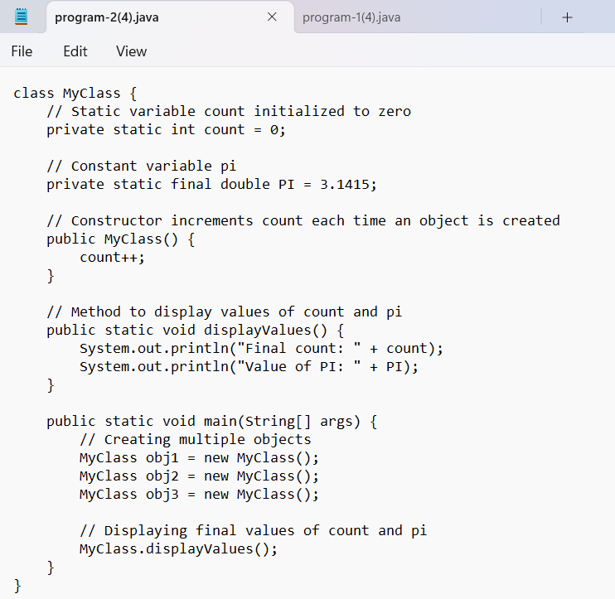

ERRORS:

|  |  |  |
| --- | --- | --- |
| **SNO.** | **Error message** | **Error rectification** |
| 1. | Error: non-static variable count cannot be referenced | Change count++ to my_class.count++ inside the constructor. |
| 2. | Error: non-static method display() cannot be referenced | Make display() a static method or call display() using an object instance. |
| 3. | Error: non-static variable pi cannot be referenced | Use an instance of my_class to access pi, like obj1.pi. |

OUTPUT:

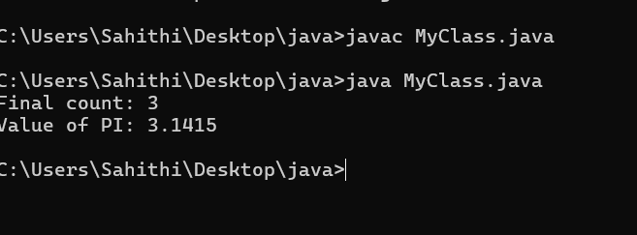

CONCEPTS KNOWN:

* static int count is shared among all instances of my_class.
* It is incremented every time an object is created.
* final ensures that pi remains constant throughout execution.
* The constructor my_class() increases count each time an object is instantiated.
* This demonstrates object creation and constructor execution

INTERVIEW QUESTIONS:

* What is the main difference between “method overloading” and “method over-riding”?
* What is an abstract class and how it is different from an interface?
* What is polymorphism and inheritance, give suitable examples for this?
* How does inheritance work in java?

Week 05

**PROGRAM-1:**

**AIM: Create a calculator using the operations including addition, subtraction, multiplication, and division using multi-level inheritance and display the desired output.**

**Hint: collect required variables using super class, create each class for a parameter and each class must contain a method.**

**CODE:**

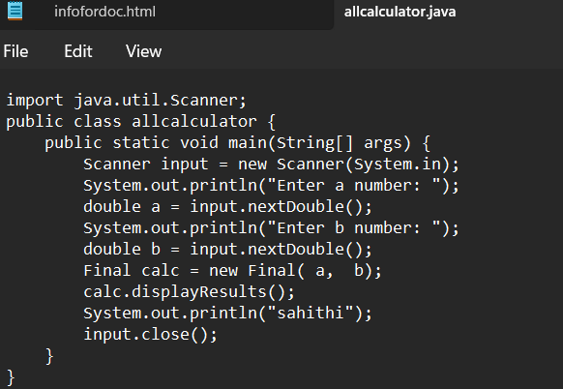

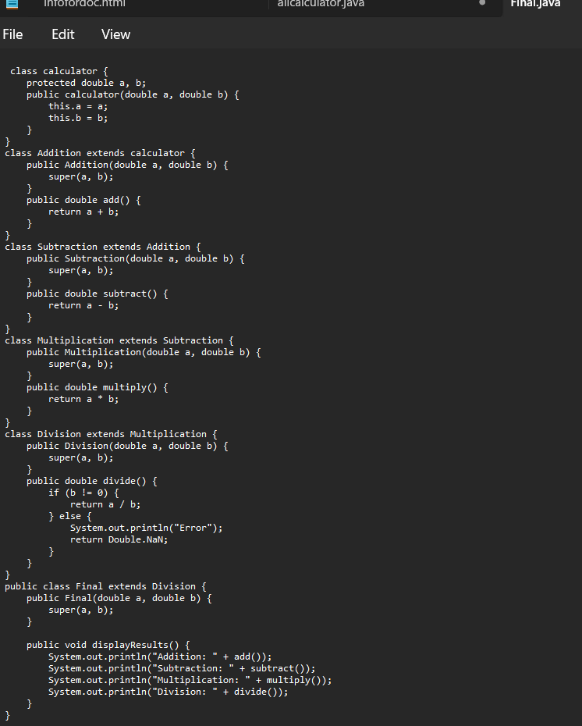

**OUTPUT:**

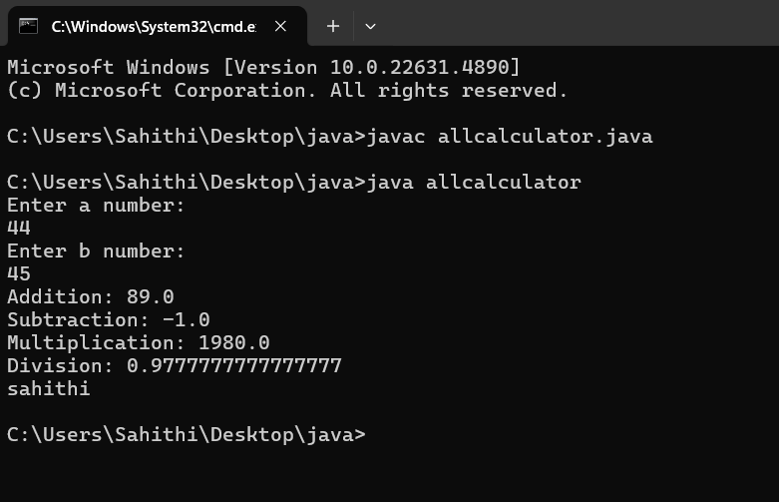

**IMPORTANT POINTS:**

1. To get the inputs from the user we use import java.util.Scanner; this is a package.
2. Scanner class is used to get the user input.
3. In java.util.Scanner, the java.util is a package while Scanner is a class of the java.util package.
4. To import a whole package, end the sentence with an asterisk sign(*).

**ERRORS:**

**ERRORS:**

|  |  |
| --- | --- |
| **Code Error** | **Code rectification** |
| 1. not providing the return method correctly. 2. Not mentioning super to obtain the super class constructor. | 1. After declaring methods, we must provide the return method correctly. 2. To obtain the super class we need to mention super. |

**CLASS DIAGRAM:**

|  |
| --- |
| Calculator |
| * a : double * b : double |
| + Calculator (a,b) |

+

|  |
| --- |
| Addition |
| + add() : double |

|  |
| --- |
| Subtraction |
| + subtract() : double |

|  |
| --- |
| Multiplication |
| + multiply() : double |

|  |
| --- |
| Divison |
| +divide() : double |

**PROGRAM-2:**

**AIM:** A vehicle rental company wants to develop a system that maintains information about different types of vechicles available for rent the company rents out cars and bikes, and they need a program to store details about each vehicle, such as brand and speed( should be in super class)

1. cars should have an additional property: no.of doors
2. Bikes should have a property indicating whether they have gears or not.
3. The system should also include a function to display details about each vehicle and indicate when a vehicle is starting.
4. Every class should have a constructor

**Question:**

1. Which oops concept is used in the above program
2. If the company decides to add a new type of vehicle, Truck, how would you modify the program?
3. Truck should include an additional property capacity (in tons)
4. Create a showTruckdetails() method to display the truck’s capacity.
5. Write a constructor for Truck that initializes all properties
6. Implement the truck class and update the main method to create a Truck object and also create an object for car and bike sub classes Finally, display the details.

**IMPORTANT POINTS:**

1. a constructor helps in initializing an object that doesn't exist.
2. a method performs functions on pre-constructed or already developed objects.
3. a double method can represent more decimal point numbers than float method.
4. the void keyword in java is used to specify that a method does not return any value. it is a return type that indicates the method performs a function and doesn't produce a result.

**Answer for Q1:**

The oops concepts used in the above program are:

Inheritance, encapsulation, polymorphism, abstraction.

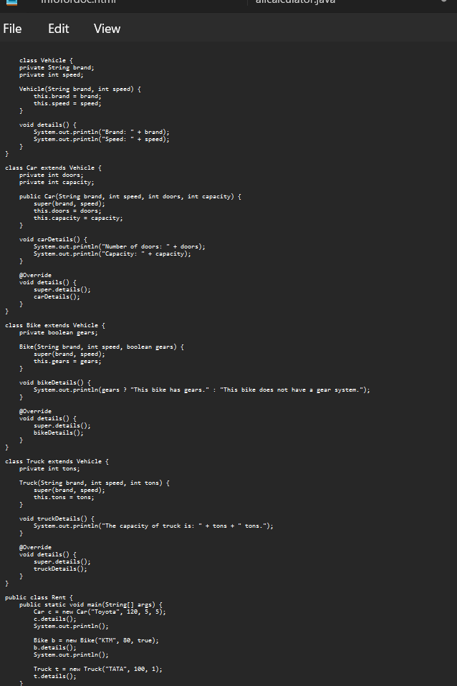

Output:

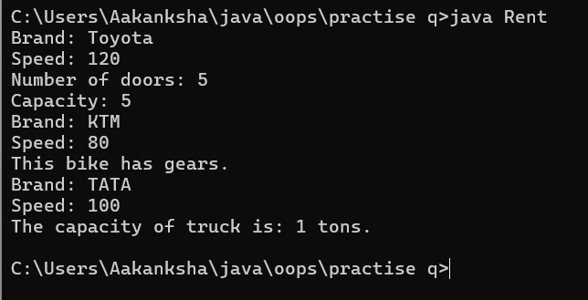

**ERROR TABLE:**

|  |  |
| --- | --- |
| Code Error | Code rectification |
| 1. Declaring two superclasses inside the same file. 2. Not declaring the variable using ‘this’ keyword inside the constructor. | 1. Make two separate files to save the two super classes. 2. Declare the variable using this keyword to run the program. |

|  |
| --- |
| Vehicle |
| -Brand : string  -Speed: int |
| + init (brand, speed)  + start_vehicle()  + display_details() |

**CLASS DIAGRAM:**

|  |
| --- |
| Bikes |
| -has gears:bool |
| +int (brand, speed,  has gears);  +display deatails(); |

|  |
| --- |
| Car |
| -no.of.doors:int |
| +int (brand, speed,  No.of doors);  +display deatails(); |

|  |
| --- |
| Truck |
| -Capacity:float |
| -Show truck detais();  +display deatails(); |

**WEEK 06:**

**PROGRAM-1:**

**AIM: Write a java program to create a vehicle class with a method displayinfo(). Override this method in the car subclass to provide specific information about car (car company, seating capacity, petrol or not).**

**CODE:**